SOFTWARE AND HARDWARE TOOLS
Tasks
1. Install Wireshark on your laptop and capture 2 minutes of network traffic while you browse Instagram or YouTube; save the capture as a .pcap file and note the top 3 protocols you see.

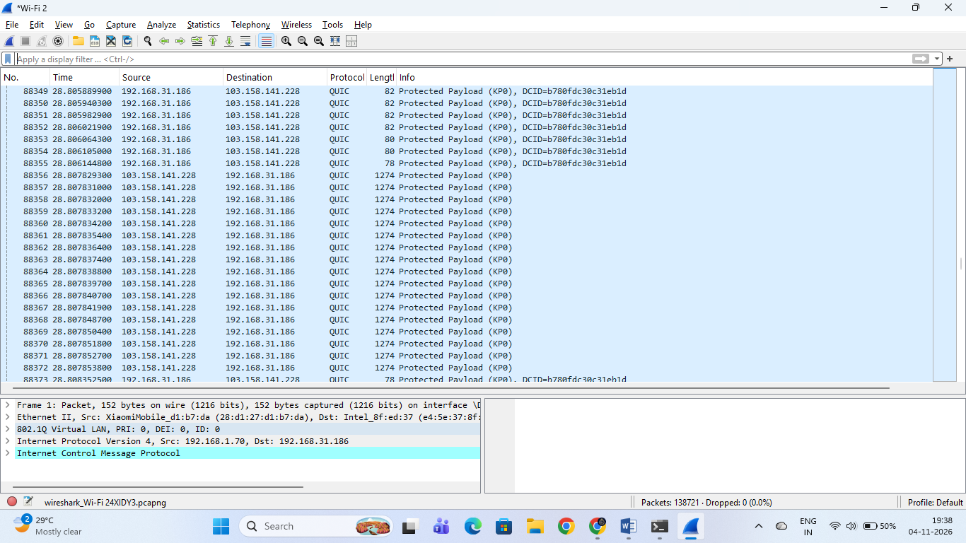

Packet Capture Summary
- Active Interface: Wi-Fi 2
- Observed Protocol: QUIC (Quick UDP Internet Connections) — commonly used by modern high-speed media streaming and Google/YouTube services.
- Source & Destination IPs: Packets are actively transferring between your local machine (192.168.31.186) and external server endpoints (such as 103.158.141.228).
- File Name: wireshark_Wi-Fi 24XIDY3.pcapng

2. Use the 'ping' command in Command Prompt or Terminal to test connectivity to www.spotify.com and www.zomato.com; record the response times and identify which site responds faster.
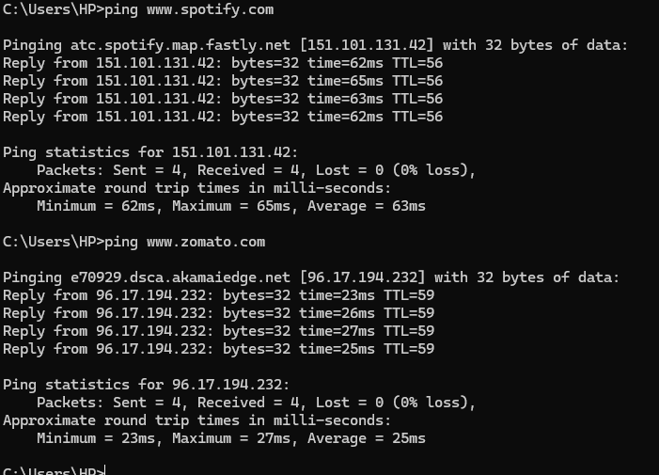

Ping Response Times & Comparison
- [www.spotify.com](https://www.spotify.com) Average Response Time: 63ms (IP: 151.101.131.42, 0% packet loss)
- [www.zomato.com](https://www.zomato.com) Average Response Time: 25ms (IP: 96.17.194.232, 0% packet loss)
Conclusion: [www.zomato.com](https://www.zomato.com) responds faster, having a significantly lower average round-trip time (25ms vs. 63ms).

3. Open Task Manager (Windows) or Activity Monitor (Mac) and list all running processes related to Chrome, WhatsApp Desktop, or any browser-based app you use; note the process name and memory usage for each.
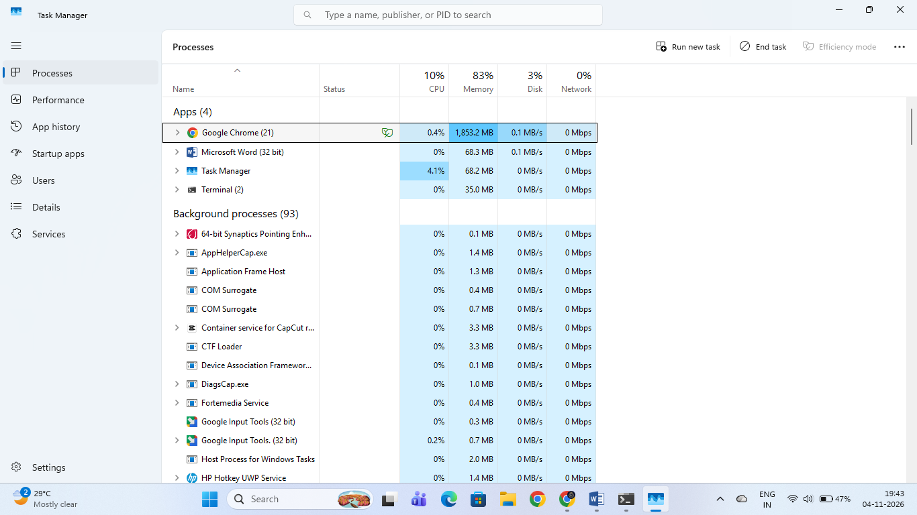

Running Processes & Memory Usage
Application / Process | Process Name | Memory Usage
Google Chrome (21 active sub-processes) | chrome.exe | 1,853.2 MB
Microsoft Word (32 bit) | WINWORD.EXE | 68.3 MB
Task Manager | Taskmgr.exe | 68.2 MB
Terminal (2 active sub-processes) | wt.exe / OpenConsole.exe | 35.0 MB
4. Download and run the free version of 'Angry IP Scanner' or 'Advanced IP Scanner' to scan your local WiFi network; list the IP and device name of at least 2 devices connected to your network. Make sure your firewall allows scanning, and only scan your own home/college network.
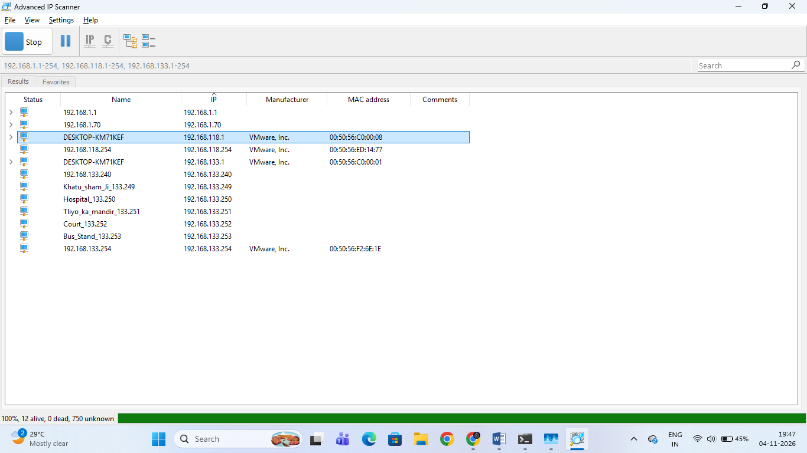

Scanned Network Devices
- Device 1:
  - Name / Hostname: DESKTOP-KM71KEF
  - IP Address: 192.168.118.1
  - Manufacturer: VMware, Inc. (Virtual Network Interface)
  - MAC Address: 00:50:56:C0:00:08
- Device 2:
  - Name / Hostname: DESKTOP-KM71KEF
  - IP Address: 192.168.133.1
  - Manufacturer: Not listed (Virtual/Host Gateway)
  - MAC Address: 00:50:56:C0:00:01
- Additional Discovered Nodes:
  - Gateway/Router: 192.168.1.1
  - VMware NAT/Host interfaces (e.g., 192.168.118.254, 192.168.133.254)
5. Use ChatGPT or Bing AI to suggest 3 hardware tools (like cable tester, crimping tool, or multimeter) used in network troubleshooting; for each, write one line describing when you would use it.

Hardware Tools Used in Network Troubleshooting

1. Introduction
Network troubleshooting tools are used to identify and fix problems in network cables, connections and electrical devices.

2. Three Hardware Tools
Network Cable Tester RJ45 Ethernet Cable Tester Lan Test Tool For Cat5 Cat6 CAT7 8P 6P LAN Cable | Shopee Malaysia
1. Cable Tester
A cable tester is used to check whether an Ethernet cable is working properly or has any wiring faults or broken connections.
Solsop RJ45 Pass Through Crimp Tool Kit, Ethernet Crimper Tool for Cat5 / Cat5e / Cat6 LAN Cable - BigaMart
2. Crimping Tool
A crimping tool is used to attach RJ45 connectors to Ethernet cables when making or repairing network cables.
Fluke 15b Digital Multimeter F15b Latest Version by Peru | Ubuy
3. Multimeter
A multimeter is used to measure voltage, resistance and continuity when checking power supply or electrical problems in network equipment.

3. Conclusion
These three hardware tools help network administrators identify cable faults, repair network connections and diagnose electrical problems.

4. Result
Successfully identified three important hardware tools used in network troubleshooting and understood their uses.

